

Internet Programming

Project Report 1



***Team Members***

Mohamed Adel Lotfy 18P1724

Adel Asaad Sarofeim 18P2949

Abdelrahman Tarek Mahdy 18P7159

***Chosen Topic***Online Library

***Supervisor***

Dr. Hesham Farag

# Home Page:

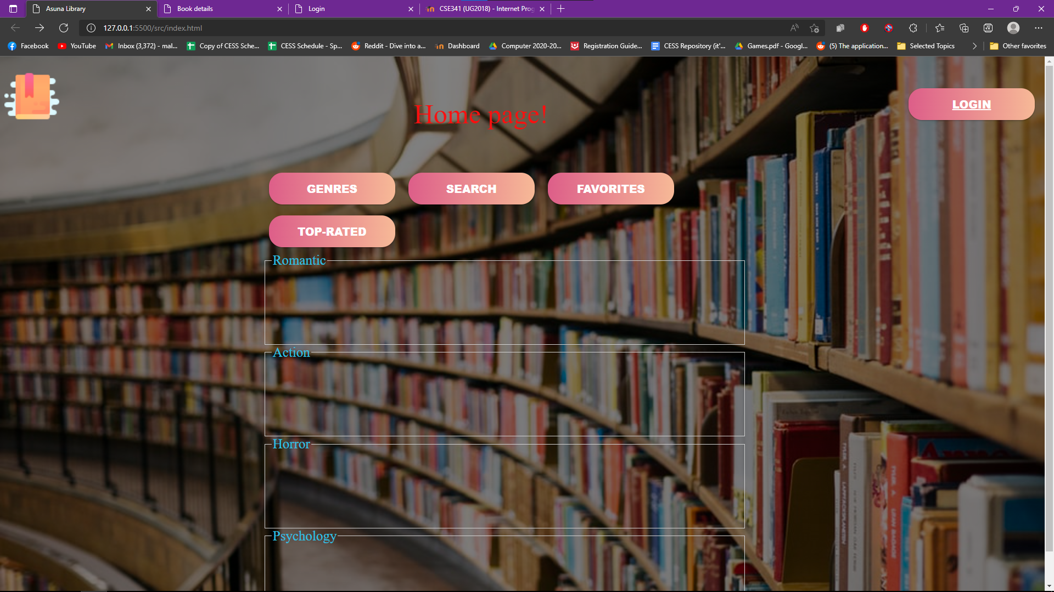

This is our first page where the user will have a set of buttons each of them opens another page, for example: “GENRES” button will take the user to a new page with compacted icons for different genres where upon picking a genre another webpage will open displaying all available books of that specific genre!



The search button will take us to a new webpage where upon writing a book name either the book will be displayed or the user will get an alarm that the book is not available.

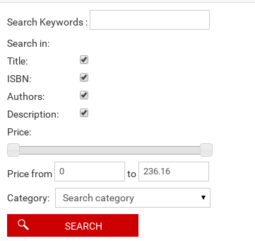

The favorites button will ask the user to login in order to be able to display that user`s favorite books. While the Top-rated button will show the most rated books in general by other readers.

# Login Page:

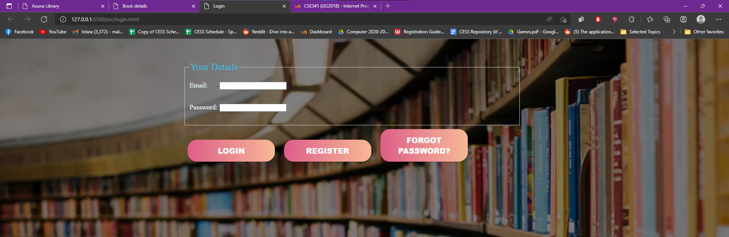

The login page will take the info from the user and compare it with the database confirming if he already exists or not, if the user exists he will login and have access to his favorite books and other perks.

If the user doesn`t exist a warning will appear asking the user to re-check his credentials or use the forgot password button!

Unregistered users will find a Register button in order to make a new account on the website by that it adds the data to the database.

# Book Details Page:

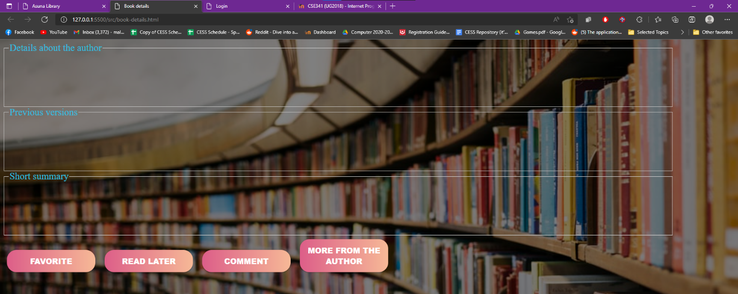

Whenever the user chooses a book, this page will appear (different books have different versions of the same page) showing:

* Details about the author
* Previous versions and related books (if exist)
* Short summary

A set of buttons will be provided too to enable the user to choose whether to:

* Add/Remove it from favorites list.
* Add/Remove from read later list.
* Add a comment.
* View other works from the same author(s).